Mark


Northwestern Polytechnical University

Software Engineering Project Report

Title of project
Student Name
Student ID
Submit Date

Directory
Chapter 1 Development plan 1
1.1 Introduction 1
1.1.1 Purpose 1
1.1.2 Scope of Project 1
1.2 Developing tools and environment 1
1.2.1 Hardware 1
1.2.2 Software 1
1.2.3 Other 1
1.3 Project Management 1
1.3.1 Schedule 1
1.3.2 Team Organization and Responsibilities 1
1.4 Software life cycle model 1
1.5 Glossary 1
Chapter 2 Requirement analysis 2
2.1 Introduction 2
2.2 Functional requirements 2
2.2.1 Function1 2
2.2.2 Function2 2
2.2.3 Function3 2
2.3 Nonfunctional requirements 2
2.3.1 Performance requirements 2
2.3.2 Security requirements 2
2.3.3 Other requirements 2
Chapter 3 System and function design 3
3.1 System architecture 3
3.2 Use case diagram 3
3.3 Package/Module diagram 3
3.4 Functional description 3
3.4.1 Function1 3
3.4.2 Function2 3
3.4.3 Function3 3
3.5 Nonfunctional description 3
3.6 Data description 3
Chapter 4 Detail design 4
4.1 Class diagram 4
4.2 ClassA/ModuleA 4
4.2.1 Variable list 4
4.2.2 Function list 4
4.2.3 FunctionA 4
Chapter 5 Programming 5
5.1 Coding rules 5
5.2 Techniques in programming 5
5.3 Difficulties in programming 5
Chapter 6 Testing 6
6.1 Test plan 6
6.1.1 Test environment 6
6.1.2 Test team responsibility 6
6.2 Unit Test 6
6.2.1 Test case 6
6.2.2 Test result 6
6.3 Function Test 6
6.3.1 Test case 6
6.3.2 Test result 6
6.4 System Test 6
6.4.1 Test case 6
6.4.2 Test result 6
6.5 Test Summary 6
Chapter 7 Summary 7
7.1 Project summary 7
7.2 Technical summary 7

/*Template user guide：
This template can be used for documenting a complete software development project.
Please extend or tailor it according to the practical software size or special requirement.
But the following sections marked with “*“must be filled:
Chapter1 Development plan
1.1 Introduction *
1.2 Developing tools and environment*
1.3 Project Management*
1.4 Software life cycle model
1.5 Glossary
Chapter2 Requirement analysis
2.1 Introduction *
2.2 Functional requirements *
2.3 Nonfunctional requirements
Chapter3 System and function design
3.1 System architecture *
3.2 Use case diagram *
3.3 Package/Module diagram
3.4 Functional description *
3.5 Nonfunctional description
3.6 Data description
Chapter4 Detail design
4.1 Class diagram *
4.2 ClassA/ModelA *
Chapter5 Programming
5.1 Coding rules *
5.2 Techniques in programming
5.3 Difficulties in programming
Chapter6 Testing
6.1 Test plan
6.2 Unit test *
6.3 Function test *
6.4 System test
Chapter7 Summary
7.1 Project summary*
7.2 Techniques summary *
*/

Development plan

Introduction

Purpose
content

Scope of Project
content

Developing tools and environment

Hardware
content

Software
content

Other
Network. etc

Project Management

Schedule

Team Organization and Responsibilities
content

Software life cycle model

Glossary

Requirement analysis

Introduction

Functional requirements

Function1
Text description or use case diagram

Function2
Text description or use case diagram

Function3
Text description or use case diagram

Nonfunctional requirements

Performance requirements
content

Security requirements
content

Other requirements
Availability, Maintenance, Usability, etc

System and function design

System architecture

Package/Module diagram

Functional description

Function1
Detail Content

Function2
Detail Content

Function3
Detail content

Nonfunctional description

Data description

Detail design

Class diagram

ClassA/ModuleA

Variable list
Important variable definition (meaning, type, value range, default value, etc)

Function list
Function name, meaning, parameter data type, return value

FunctionA
Flow chart

Programming

Coding rules

Techniques in programming
Pairing programming, etc

Difficulties in programming

Testing

Test plan

Test environment
content

Test team responsibility
content

Unit Test

Test case

Test result
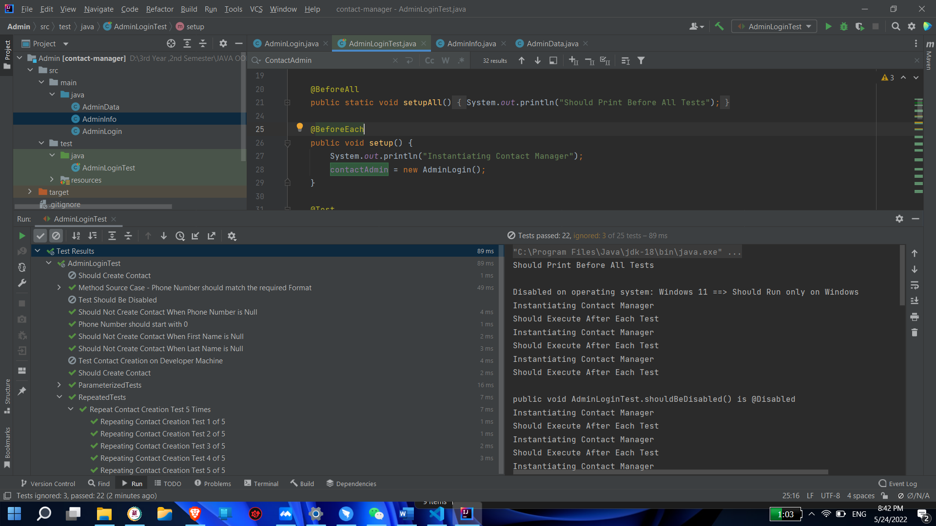

Function Test

Test case
content

Test result
content

System Test

Test case
content

Test result
Content

Test Summary

Summary

Project summary
Work List:
Member | Work | Size (LOC)

Technical summary

Reference

